La Catrina Christine Delsol
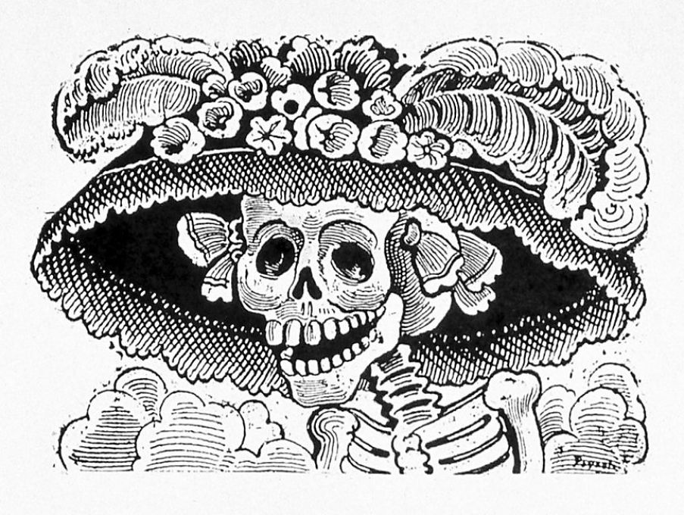
In many years of traveling to Mexico I've often encountered a tall, elegantly attired female skeleton sporting an extravagantly plumed hat — in books, in cartoons, on posters, in figures and in the works of some of Mexico's greatest artists. I gradually realized that she is not just one among the proliferation of skulls and skeletons in Mexican art and lore, but a distinct figure named La Catrina.
"Catrina has come to symbolize not only El Día de los Muertos and the Mexican willingness to laugh at death itself, but originally catrina was an elegant or well-dressed woman, so it refers to rich people," de la Torre said. "Death brings this neutralizing force; everyone is equal in the end. Sometimes people have to be reminded."
La Catrina as we know her originated with Jose Guadalupe Posada, considered the father of Mexican printmaking. He became famous for calaveras (skulls or skeletons) images that he wielded as political and social satire, poking fun at every imaginable human folly. His influence on Diego Rivera, Jose Clemente Orozco and other great artists of their generation was incalculable.
"La Catrina has been iterated over time," de la Torre said. "It's not just Posada and his work in 1910. There are layers of history. The image and the woman in death goes back to the ancient Aztec period. Posada took his inspiration from Mictecacihuatl, goddess of death and Lady of Mictlan, the underworld."
The Day of the Dead brings into focus one of the greatest differences between Mexican and U.S. cultures: the 180-degree divide between attitudes toward death. Mexicans keep death (and by extension their dead loved ones) close, treating it with familiarity — even hospitality — instead of dread. La Catrina embodies that philosophy, and yet she is much more than that.

